

**YEAR: 7**

**2024**

**SUBJECT: Science**

**TEST: Ecosystems**

**TIME: 50 minutes**

**QUESTIONS: 10 Multiple Choice (10 marks)**

**Short Answer (37 marks)**

**TOTAL MARKS: 47 marks**

**DO NOT WRITE ON OR MARK THIS PAPER**

**SECTION ONE—MULTIPLE CHOICE** (10 marks)

This section has **10** questions. Answer **all** questions on the separate Multiple-choice Answer Sheet provided.

1. Plants are examples of:
   1. decomposers
   2. carnivores
   3. producers
   4. consumers
2. Bacteria and fungi belong to an ecosystem group called:
   1. herbivores
   2. decomposers
   3. plants
   4. composers
3. Which of the following is the best definition for an omnivore?
   1. an organism that feeds on dead things
   2. an animal that eats plants only
   3. an organism that eats both plants and animals
   4. an organism that eats animals
4. What do the arrows in a food web and food chain represent?
   1. the organism that eats the other
   2. the flow of energy
   3. the organism that is eaten by the other
   4. the herbivores in the system
5. As you move up the food web:
   1. the number of organisms stays the same, but the size decreases
   2. the number of organisms increase
   3. the number of organisms decreases
   4. the number of organisms stays the same, but the size increases
6. An autotroph is an organism which:
   1. makes their own energy
   2. has to consume other organisms to gain energy
   3. consumes decaying organisms
   4. is introduced into a new ecosystem

Use the food web below to answer questions 7-9.

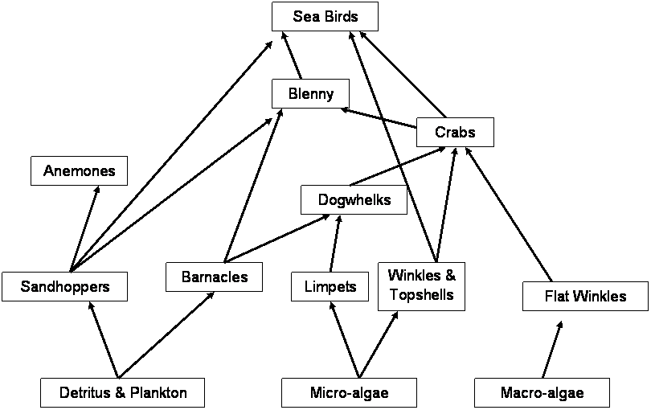

1. How many primary consumers are in the food web?
   1. 2
   2. 5
   3. 3
   4. 4
2. How many organisms are both secondary and tertiary consumers in this food web?
   1. 3
   2. 2
   3. 5
   4. 4
3. If decomposers were removed from this food web:
   1. nutrients would not be returned to the soil in order for producers to grow healthy
   2. waste and dead organisms would pile up
   3. there would be a break down in the flow of energy
   4. all of the above
4. Which of the following is not an introduced species?
   1. cane toad
   2. rabbit
   3. feral cat
   4. kangaroo

**END OF MULTIPLE CHOICE SECTION**

*Please continue with short answer section in the answer book.*



**SEMESTER TWO 2023**

**Ecosystems Test:**

**ANSWER BOOKLET**

**NAME:**

**FORM:** **DATE:**

|  |  |
| --- | --- |
| **I CAN STATEMENT** | **QUESTIONS** |
| **MUST**  Makes predictions about the effects of environmental change on directly-connected organisms within a food web. | 1, 2, 3, 4, 6, 10, 11, 12, 13, 14, 15, 16, 17, 20, 22, 23 & 24 |
| **SHOULD**  Makes predictions about and explains the effect of environmental change on populations within the food web. | 5, 7, 8, 18, 20, 22 &23 |
| **COULD**  Makes predictions about and explains the effect of environmental change on the entire food web or community. | 9, 19, 20 & 21 |

Multiple Choice Short Answer Total

**/37**

**/10**

**/47**

**SECTION ONE:** Multiple choice answers

Cross (X) through the correct answer.

|  |  |  |  |  |
| --- | --- | --- | --- | --- |
| **1** | a | b | c | d |
| **2** | a | b | c | d |
| **3** | a | b | c | d |
| **4** | a | b | c | d |
| **5** | a | b | c | d |
| **6** | a | b | c | d |
| **7** | a | b | c | d |
| **8** | a | b | c | d |
| **9** | a | b | c | d |
| **10** | a | b | c | d |

**SECTION TWO: Short Answer (37 marks)**

Answer the questions in the spaces provided.

1. What is the difference between a food web and a food chain? (1 mark)

|  |
| --- |
|  |

1. Classify the following list of organisms as either a producer, consumer or decomposer (2 marks)

|  |  |
| --- | --- |
| Organism | Producer or consumer? |
| Cat |  |
| Magpie |  |
| Rose |  |
| Worm |  |

1. What is the primary source of energy for all life on earth? (1 mark)

|  |
| --- |
|  |

1. Provide a definition for the following organisms in an ecosystem. (3 marks)

Decomposer:

_________________________________________________________________________________

_________________________________________________________________________________

Predator:

_________________________________________________________________________________

_________________________________________________________________________________

Heterotroph:

_________________________________________________________________________________

_________________________________________________________________________________

1. Draw a line clearly linking the term to the definition. (3 marks)

|  |  |  |
| --- | --- | --- |
| Term: |  | Definition |
| Producer |  | The process by which green plants and other organisms use sunlight to produce energy. |
| Quaternary Consumer |  | Organism that gains energy by eating other organisms. |
| Photosynthesis |  | Organism found at the start of the food chain. Always plant or plant-like organism that use sunlight to produce energy. |
| Consumer |  | First-order consumer. Organisms that eat the producer. |
| Introduced species |  | Fourth-order consumer. |
| Primary Consumer |  | Organisms that are not naturally part of the ecosystem. They were brought in by humans. |

1. **Construct** a food chain from the following information: (3 marks)

*A shark swims through the ocean in search of seals to eat. In turn, seals search for large fish to eat. Large fish have a diet of smaller fish. Floating in the water are millions of plankton. These are microscopic producer organisms that provide food for smaller fish and other herbivorous animals in the ocean.*

FOOD CHAIN

1. Use the following information to construct a food web in the box below: (5 marks)

|  |  |  |
| --- | --- | --- |
| Algae (producer)  Snail (eats algae) | Small fish (eats algae and snails)  Water beetle (eats small fish) | Frog (eats water beetles)  Snake (eats water beetles and frogs) |

1. **Examine** the food web below: (6 marks)

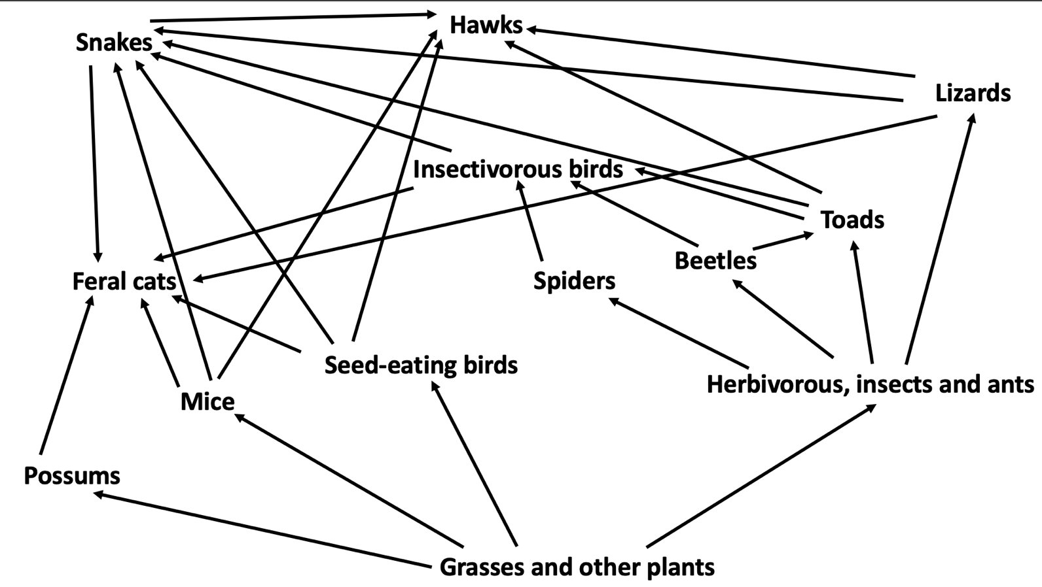

1. Identify the producer: _____________________________________________________________
2. Identify two top order consumers: ______________________, ______________________
3. Complete the food chain so that it ends with a hawk:

Plants ---> ____________ ---> _____________ ---> ___________

1. Write out a different food chain from the one above. Include a producer, and three consumers.
2. 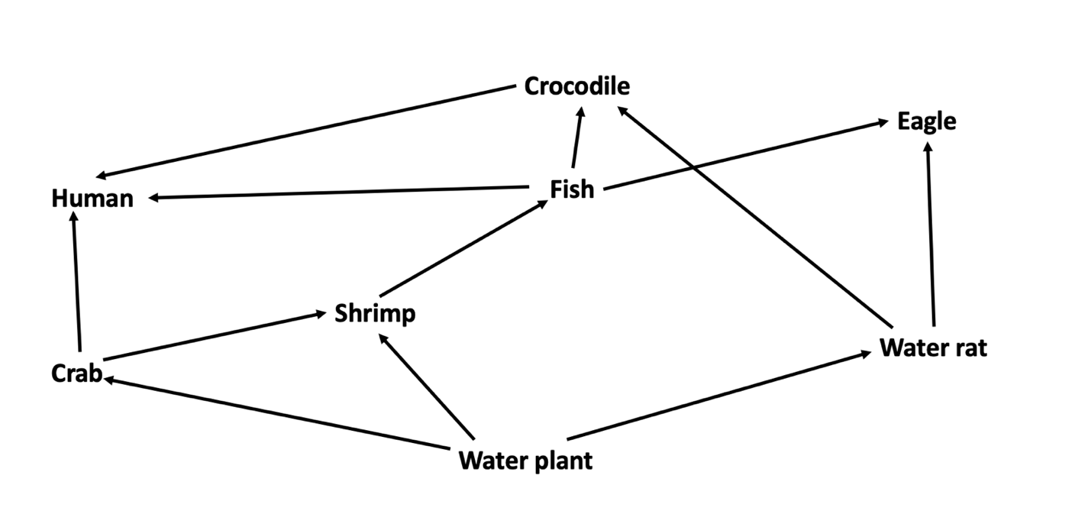Use the food web above to complete the following questions. (2 marks)
   1. Propose what would happen to the eagle population if the water plant population was significantly reduced due to rise in water temperature.

|  |
| --- |
|  |

* 1. Justify your proposal above.

|  |
| --- |
|  |
|  |
|  |

1. This food web represents a freshwater creek ecosystem.

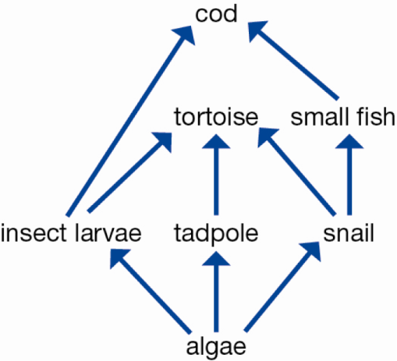

* 1. **Explain** why this community could not survive without the algae. (1 mark)

**______________________________________________________________________________________________________________________________________________________**

* 1. Draw a decomposer on the food web. (1 mark)

1. Using an **example**, describe how loss of an organism from an ecosystem can have negative effects. (3 marks)

**_______________________________________________________________________________________________________________________________________________________________________________________________________________________________________________________________________________________________________________________________________________________________________________________**

1. List **four** ways in which humans damage ecosystems. (4 marks)
   1. ______________________________________________________________________________________________________________________________________________________
   2. ______________________________________________________________________________________________________________________________________________________
   3. ______________________________________________________________________________________________________________________________________________________
   4. ______________________________________________________________________________________________________________________________________________________

**END OF TEST**

**Please go back and check your work!**